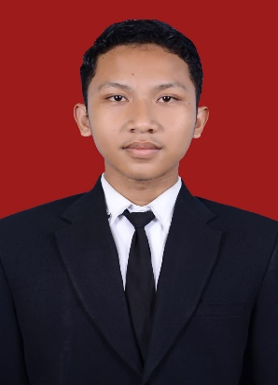
NDARU FEBRIAN PUJO LEKSONO
+6281=95423453343 | ndarupl1@gmail.com | www.linkedin.com/in/
| github.com/

Fresh graduate in Informatics Engineering with interests in AI and web development, particularly in Machine Learning, NLP, and Computer Vision. Experienced in designing, building, and deploying systems, as well as training and optimizing models for real-world applications. Possesses a solid understanding of the Software Development Life Cycle (SDLC) with a proven ability to deliver production-ready solutions.
Personal Projects / RESEARCH EXPERIENCE

Classification of Semarang Guava Cultivars Using MobileNetV2 April 2026 – Now
- Developed a CNN-based image classification model using MobileNetV2 and transfer learning.
- Performed data preprocessing, augmentation, and model evaluation using TensorFlow/Keras.
- Achieved high classification accuracy for multiple guava cultivar classes.

Academic Lecturer Information System Sep 2025 – Jan 2026
- Developed a responsive research archive management website using React.js and Tailwind CSS.
- Implemented dynamic search, filtering, sorting, and metadata-based categorization features.
- Designed modern and interactive UI components with optimized user experience.

Learning Style Detection Framework Using Deep Neural Networks Sep 2024 – Feb 2026
- Developed machine learning models using KNN, Random Forest, SVM, ANN, and Linear Regression.
- Processed and preprocessed educational datasets (OULAD) from e-learning systems.
- Performed model training, tuning, and performance evaluation.

Education Level
Universitas Amikom Purwokerto - Central Java, Indonesia Sep 2022 – Sep 2026

Organisational Experience
Forum Asisten Universitas Amikom Purwokerto – Central Java, Indonesia Sep 2024 – Sep 2025
Member
The assistant forum is a student organization under the UPT that accommodates all laboratory assistants from various courses.
- Assisted in handling courses in the field of programming.
- Guided and mentored students during practicum sessions.
- Handling courses in the field of programming.

Intermedia Universitas Amikom Purwokerto – Central Java, Indonesia Sep 2022 – Feb 2023
Member
Learning activities participated in informatics and technology.
- Participated in informatics and technology learning activities, collaborative discussions, and IT skill development programs.
- Collaborated with members in organizational and technology-related activities.
- Improved communication and teamwork skills through group activities and discussions.

Skills & Projects Experience
Hard Skills : Python, Java, JavaScript, React.js, Tailwind CSS, MySQL, TensorFlow/Keras, Machine Learning, Deep Learning, Computer Vision, Natural Language Processing (NLP), Microsoft Office Tools, GitHub.
Soft Skills :Teamwork, Communication, Used to work Under Pressure, Problem Solving.

Interest : AI Engineer, Backend Developer, Machine Learning Engineer, Data Scientist, Fullstack developer, Frontend Developer, Software Engineering, Computer Vision Engineer, Database Engineer.

